LASSWADE HIGH SCHOOL SENIOR PHASE CAREER FAIR
THURSDAY 1 FEBRUARY 2018
5PM – 7PM
Attending Organisations

Further and Higher Education
 | Atrium
 | Atrium
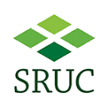 | Atrium
 | Atrium
 | Atrium
Fashion & Textiles, Galashiels | Atrium
 | Atrium

CAREERS ADVICE, VOLUNTEERING OPPORTUNITIES AND EMPLOYERS
 | Atrium
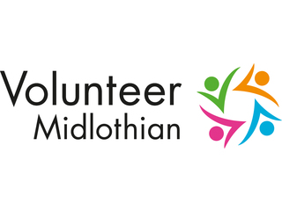 | Atrium
Lifelong Learning & Employability2424 | Atrium
Retail | Room 114/115 (first floor)
 | Room 114/115 (first floor)
 | Room 114/115 (first floor)
Airborne & Space Systems | Room 114/115 (first floor)
Naval & Marine Defence | Room 114/115

