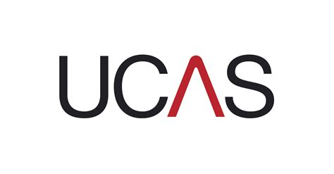
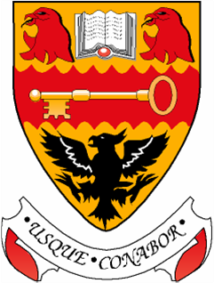
Lasswade High School UCAS Calendar
Session 2018 – 19
Date | Task | By whom and how?
20th August 2018 – 7th September 2018 | All students with intentions of applying through UCAS register online via UCAS Apply | Students online
By 7th September 2018 | Route A Applicants identify staff for reference requests | Students submit form to J Costello  J Costello distribute to staff
By 14th September 2018 | Route A drafts of Personal Statements submitted | Students to J Costello (to copy to NC and St Supp Link)
By 21st September 2018 | Route A final Personal Statements saved on UCAS Apply and applications submitted for approval | Students online
By 24th September 2018 | All Applicants identify staff for reference requests | Students submit form to J Costello  J Costello distribute to staff
By 5th October 2018 | All Route A references completed and saved on UCAS Apply | Student Support Staff online
By 12th October 2018 | All Route A applications sent to UCAS | N Chisholm online
By 26th October 2018 | All drafts of Personal Statements submitted | Students to Student Support Link by email or paper copy
By 23rd November 2018 | All final drafts of personal statements completed and saved on UCAS Apply | Students online
By 10th December 2018 | All references completed and saved on UCAS Apply | Student Support Staff online
By 17th December 2018 | All applications sent to UCAS | N Chisholm online

- Route A applicant draft personal statements reviewed by NC and Student Support link
- Reference requests submitted to J Costello. Distribute within 2 working days. Returns from staff within 7 working days to JC.
- Student Support references completed within 10 working days of notification that personal statement is completed and application submitted on UCAS Apply.
- Full application reviewed and sent to UCAS by N Chisholm within 5 working days of reference completed on UCAS Apply.

